13.1.1 Editors - Video Sequence Editor - Header - Tools and Options
Header tools and options - Preview view 1
Display Mode 1
Image Preview 1
Luma Waveform 1
Chroma Vectorscope 1
Histogram 1
Display Channels 2
Color and Alpha 2
Color 2

Header tools and options - Preview view

Just the Preview view has some options. The Sequencer view has no header options.

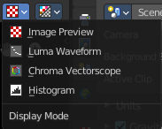
Display Mode
How to display the preview video.

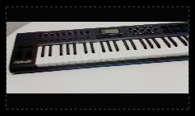
Image Preview
Displays the image material.

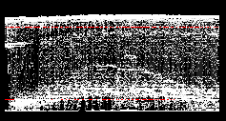
Luma Waveform
Displays the luma waveform of the image.

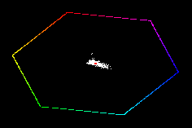
Chroma Vectorscope
Displays the chroma vectorscope of the image.

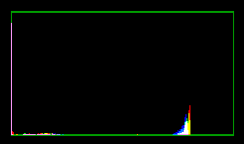
Histogram
Displays a histogram of the image.

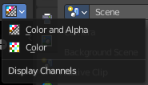
Display Channels
What channels of the video to display.

Color and Alpha
Display the color channels and alpha channel.

Color
Display just the color channels.

